Exercises

* Reformat the last code to organize the widgets *horizontally* (Hint: lookup *Row*)
* 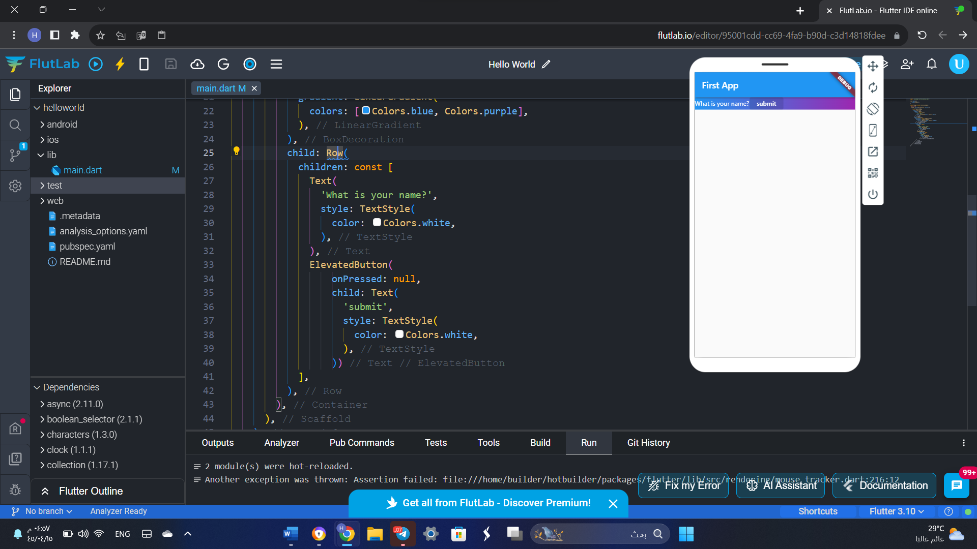
* Reformat the last code to change the background color of the *Scaffold* to **Red**.
* 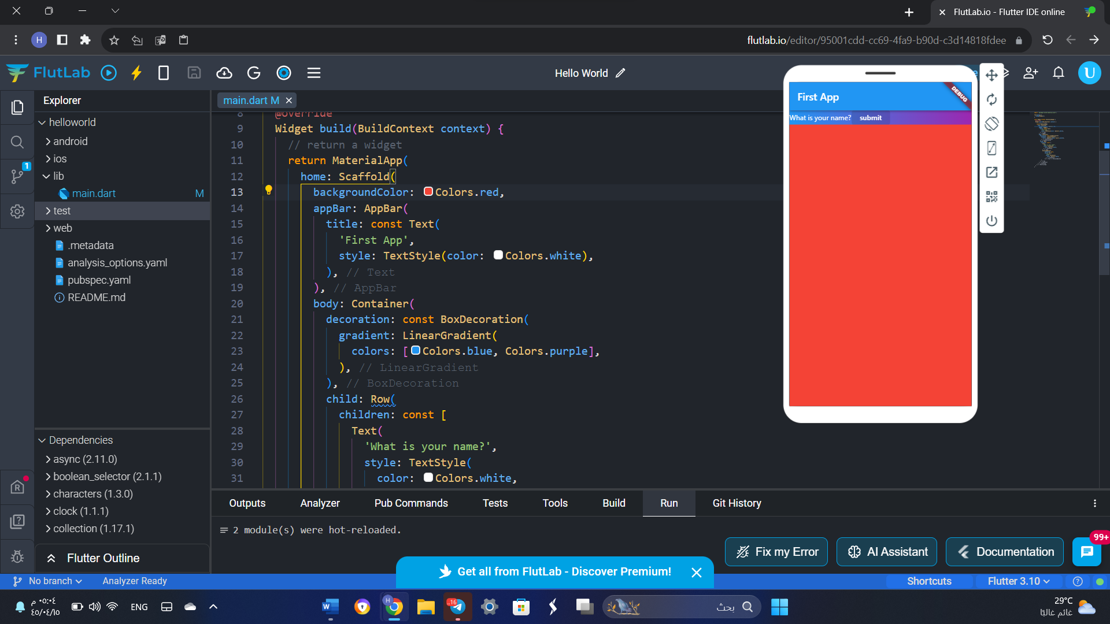
* Reformat the last code to change the *AppBar* color to **Red**.
* 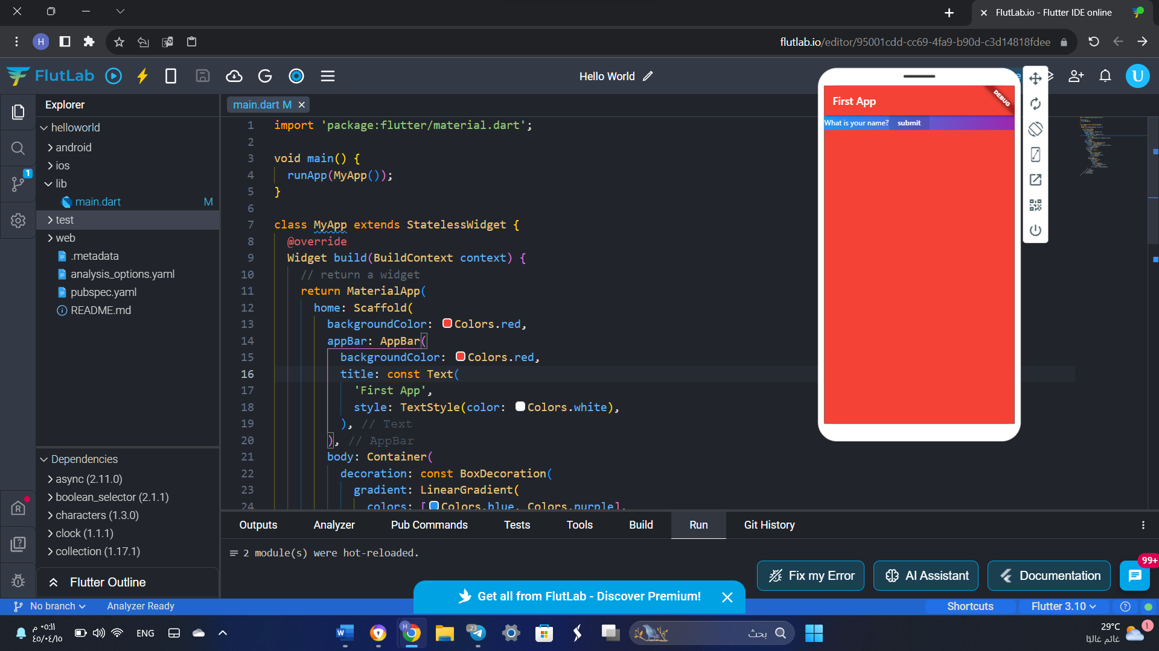
* Reformat the last code to change the start and end colors of the gradient effect (Hint: lookup *begin* and *end* in *LinearGradient*)
* 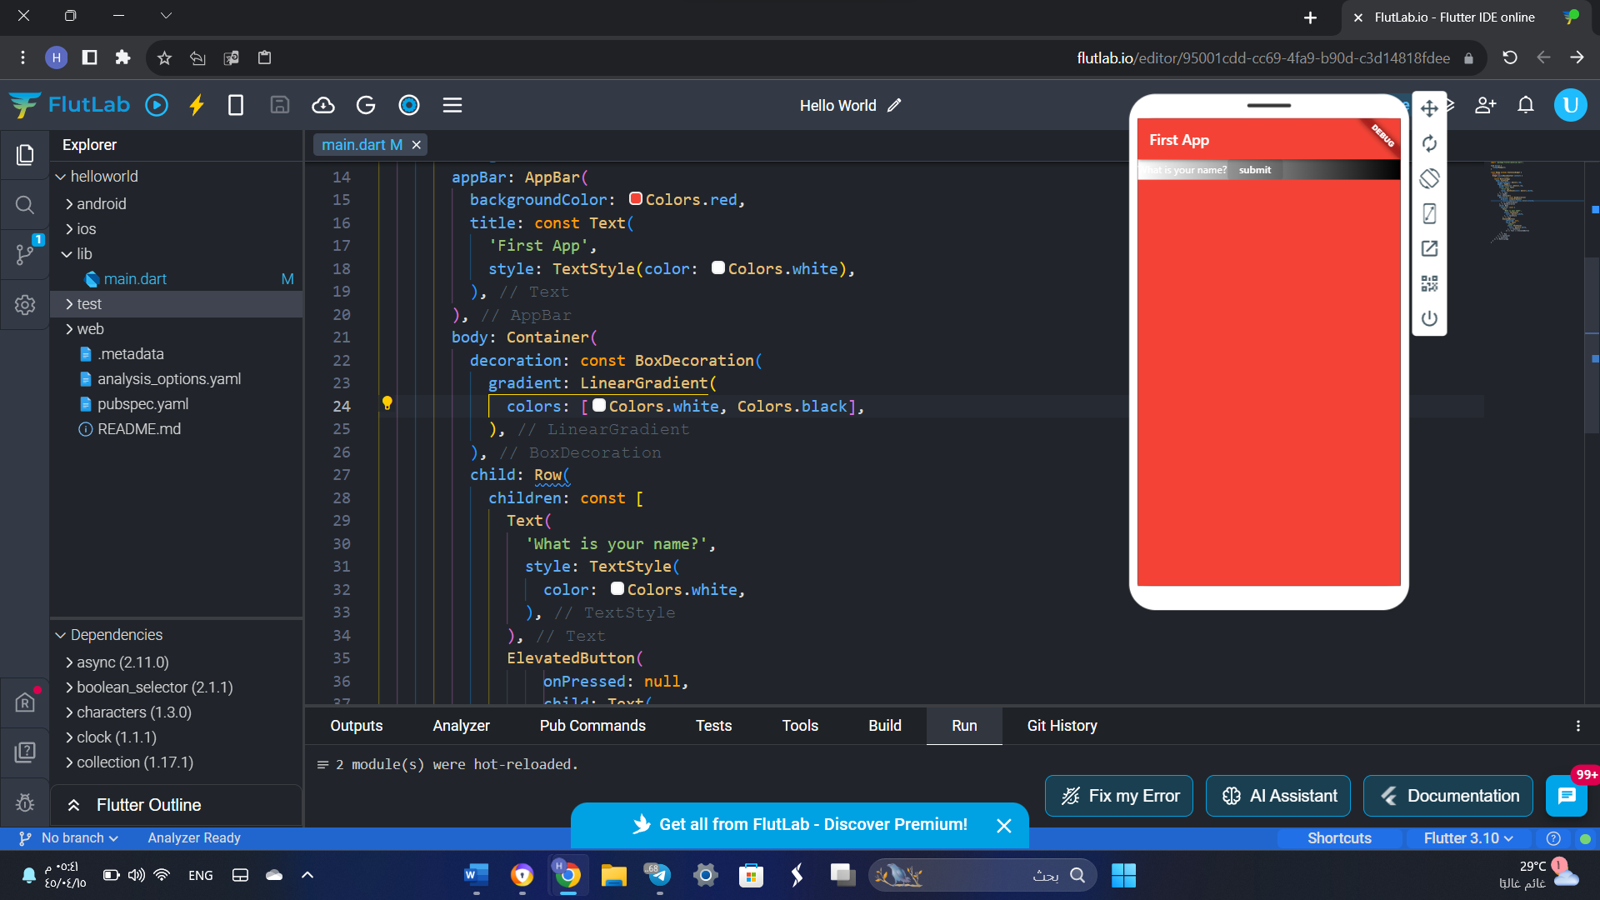
* Reformat the last code to create a new widget called *MyButton* that replaces the *ElevatedButton* widget in the code. However, it should accept the *text* as a parameter. Then, use the *MyButton* widget to create two buttons: *Submit* and *Cancel*.
* 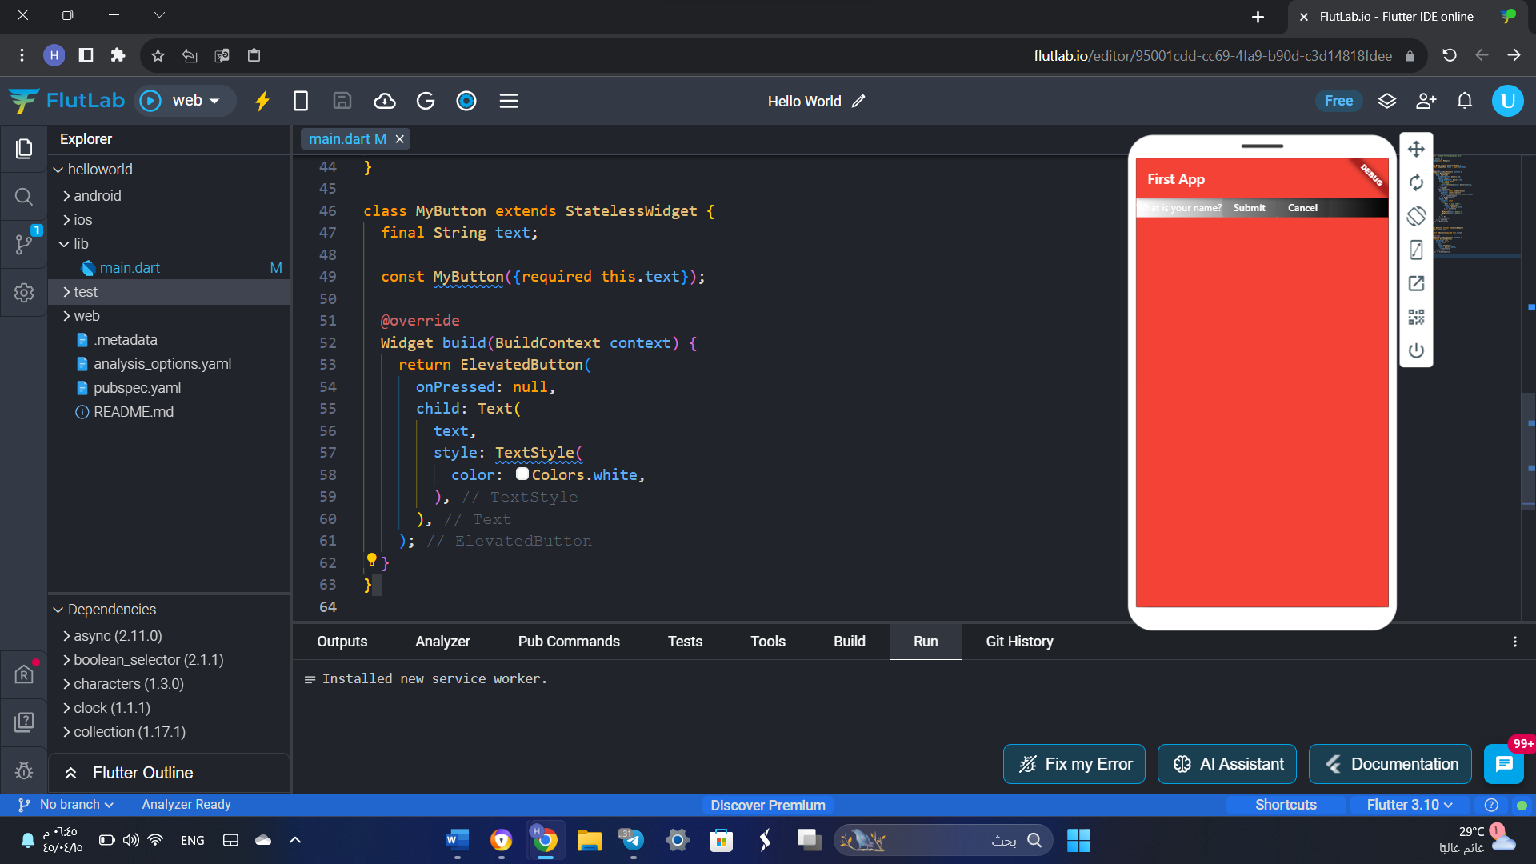 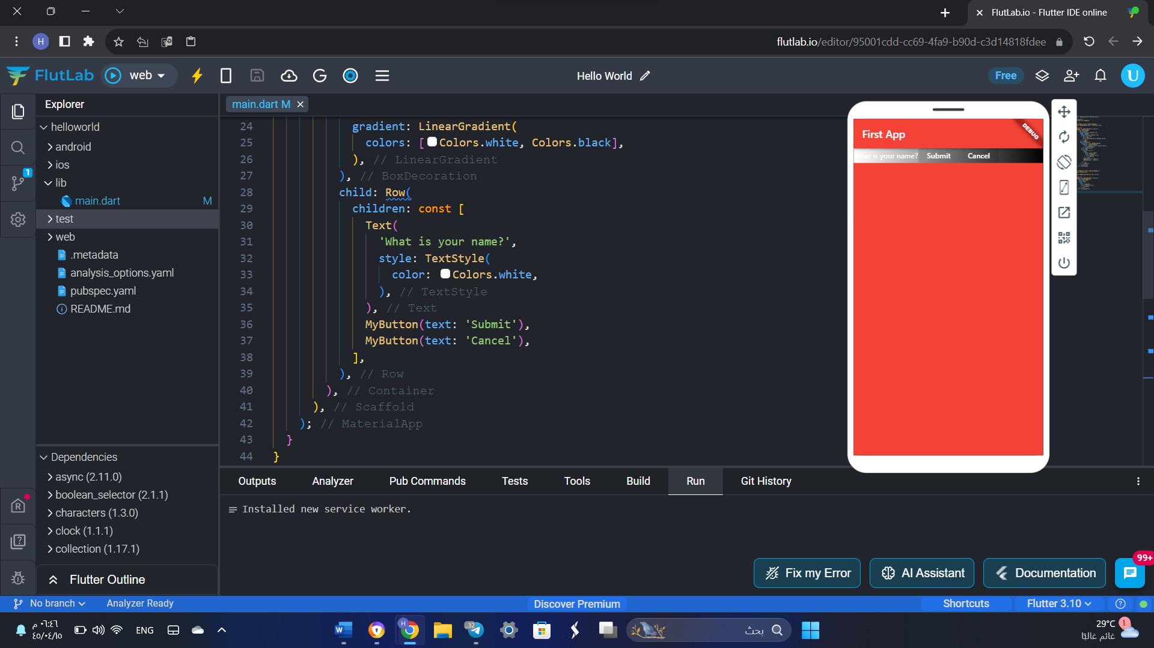
* In Flutter, it is considered a good practice to split the classes into different **.dart** files. Thus, create a new file called *my_app.dart* and move the *MyApp* class to it. Then, import the *my_app.dart* file into the *main.dart* file and fix any errors. 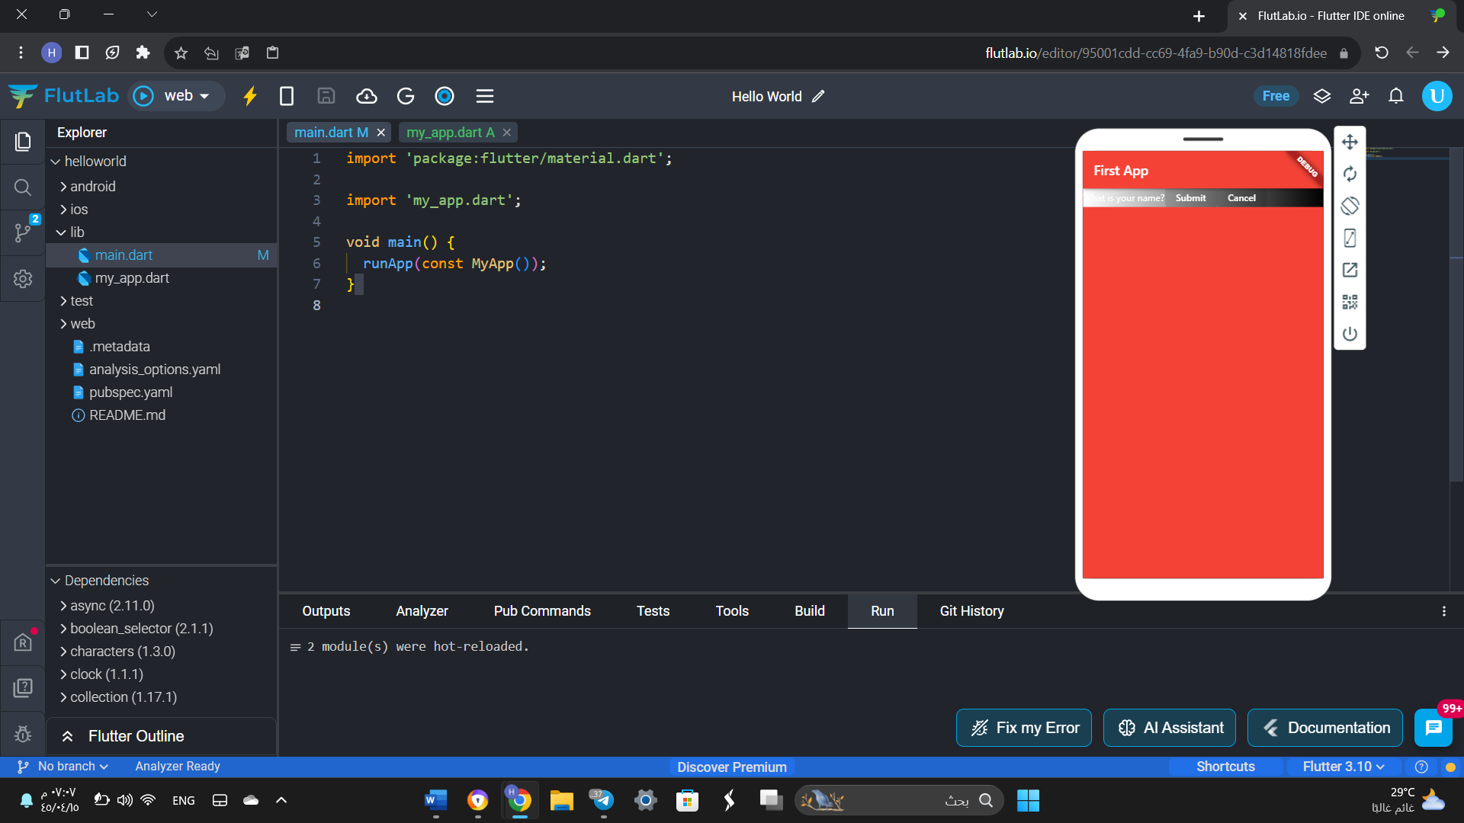 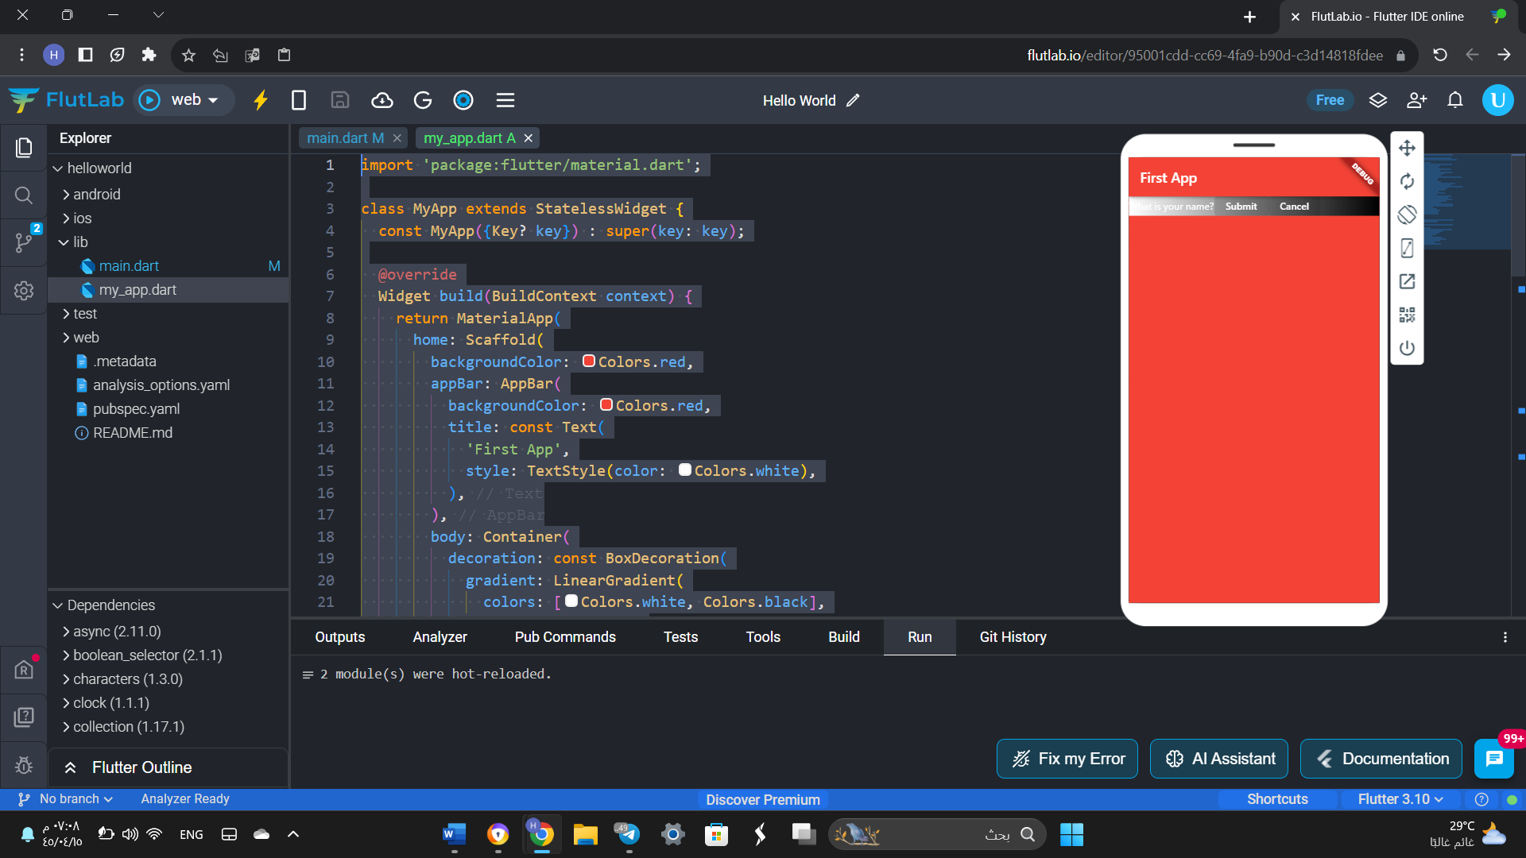
* Write the code to generate the following snapshot
* import 'package:flutter/material.dart';
* void main() {
* runApp(MyApp());
* }
* class MyApp extends StatelessWidget {
* @override
* Widget build(BuildContext context) {
* return MaterialApp(
* home: Scaffold(
* appBar: AppBar(
* title: Text('first app'),
* ),
* body: Container(
* child: Row(
* children: [
* Text(
* 'Student ID? ' + 'Your age? ' + 'Your name? ' + '\n\n\n',
* style: TextStyle(
* color: Colors.black,
* ),
* ),
* ElevatedButton(
* onPressed: null,
* child: Text(
* 'submit',
* style: TextStyle(
* color: Color(0xff8b8888),
* ),
* ),
* ),
* ElevatedButton(
* onPressed: null,
* child: Text(
* 'submit',
* style: TextStyle(
* color: Color(0xff8b8888),
* ),
* ),
* ),
* ElevatedButton(
* onPressed: null,
* child: Text(
* 'submit',
* style: TextStyle(
* color: Color(0xff8b8888),
* ),
* ),
* )
* ],
* ),
* ),
* ),
* );
* }
* }

